Infosys Springboard Virtual Internship 6.0 Completion Report

Team Details <Do not mention any personally identifiable information like email ID, institute details, mobile phone number etc.>

Batch Number: 13 Online Medication and Prescription Tracker
Start date : 28-01-2026
Names:
- Akshata Kapare
- Priyansh Patel
- Khushi Sharma
- Shreya Badri
Internship Duration: 8 Weeks

1. Project Title
Online Medication and Prescription Tracker

2. Project Objective
- To digitalize prescription management processes
- To enable real-time medication tracking and adherence monitoring
- To provide automated alerts and reminders
- To ensure secure storage and easy retrieval of medical records
- To improve communication between doctors, patients, and caregivers
- To integrate AI for intelligent health assistance

3. Project description in detail
Prescripto is a web-based application developed to streamline prescription management and medication tracking for healthcare stakeholders.
- Doctors can create and manage digital prescriptions
- Patients can view and track medications
- Caregivers assist patients in monitoring schedules
- Administrators manage users and system activities
The platform also includes:
- Automated reminders for medication schedules
- Secure storage of prescription records
- Real-time access to health data
- AI-powered chatbot for instant medical guidance
This improves communication, reduces errors, and enhances healthcare efficiency.
4. Timeline Overview
 | Activities Planned | Activities Completed
Week 1 | Requirement gathering, project scope definition, and resource allocation | Requirements finalized, project scope documented, team roles assigned
Week 2 | Team GitHub Repository,Theme Selection,System flowchart,JWT Based Authentication | Team GitHub Repository,Theme Selection,System flowchart,JWT Based Authentication
Week 3 | Develop RESTful APIs for different modules,Integrate backend with database (MySQL, MongoDB, Firebase, etc.) | Develop RESTful APIs for different modules,Integrate backend with database (MySQL, MongoDB, Firebase, etc.)
Week 4 | Implement user authentication and authorization, Test APIs using tools like Postman | Implement user authentication and authorization, Test APIs using tools like Postman
Week 5 | Implement validation and error handling, Optimize database queries and performance | Implement validation and error handling, Optimize database queries and performance
Week 6 | Complete the Doctor module functionalities | Completed the Doctor module functionalities
Week 7 | Integrate Google Gemini API for AI Health Assistant, Developed AI service layer for processing user queries, Create REST APIs for chatbot interaction (request–response handling),  Implemente API communication using RestTemplate | Integrated Google Gemini API for AI Health Assistant, Developed AI service layer for processing user queries, Created REST APIs for chatbot interaction (request–response handling),  Implemented API communication using RestTemplate
Week 8 | Develope logic for medicine information and side-effect responses, Handle error handling and API response optimization, Coordinate with frontend for chatbot integration | Developed logic for medicine information and side-effect responses, Handled error handling and API response optimization, Coordinated with frontend for chatbot integration

5a. Key Milestones
Milestone | Description | Date Achieved
Project Kickoff | Project kickoff defined objectives, scope, team roles, technology selection, and initial system design including flowcharts and authentication setup. | 2 – Feb - 2026
Prototype/First Draft | Developed initial backend APIs, database integration, and implemented user authentication with basic module structure. | 17- Feb - 2026
Mid-Term Review | Completed core backend functionalities, validation, error handling, and Doctor module; reviewed progress and optimized system performance. | 3 - Mar - 2026
Final Submission | Integrated AI Health Assistant using Gemini API, completed system integration, and finalized project documentation. | 18 - Mar - 2026
Presentation | Prepared and delivered the final project presentation demonstrating system features and outcomes. | 2 - Apr - 2026

5b. Project execution details

• Requirement Analysis – Identified user requirements for doctors, patients, caregivers, and administrators; defined project scope and objectives.
• Technology Selection – Selected Java (Spring Boot) for backend development, React for frontend, MySQL for database management, and Python for AI/analytics.
• System Design – Designed system architecture, database schema, workflow diagrams, and user interface layouts.
• Database Design – Structured tables for users, prescriptions, medication schedules, and system logs ensuring efficient data management.
• Backend Development – Developed RESTful APIs, implemented business logic, and integrated JWT-based authentication for secure access.
• Frontend Development – Built responsive and user-friendly interfaces including dashboards for doctors, patients, caregivers, and admin.
• Medication Tracking & Notification System – Implemented logic for tracking medication schedules and sending automated reminders.
• Integration – Integrated frontend with backend services and ensured smooth data flow between modules.
• Testing & Debugging – Performed unit testing, integration testing, and resolved bugs to ensure system reliability.
• Deployment & Documentation – Prepared project documentation, user manual, and demonstrated the final working system.

6. Snapshots / Screenshots
Step 1 : Go to Github and clone the Repository in your system then open in VS Code to do the execution , here is the github repo link : Akshatakapare_Online_Medication_And_Prescription_Tracker_Infosys
Step 2: Open MySQL and run: CREATE DATABASE prescripto_db_main;

Step 3 : Run Backend: ./mvnw spring-boot:run

Step 4 : Frontend Setup : cd frontend

Step 5: Install dependencies
npm install
npm i react-router-dom
npm i axios
npm install tailwindcss @tailwindcss/vite

Step 6 : Start the application with : npm run dev
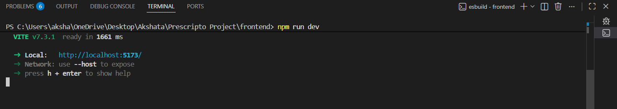

Here is the Landing page with basic navigation for user
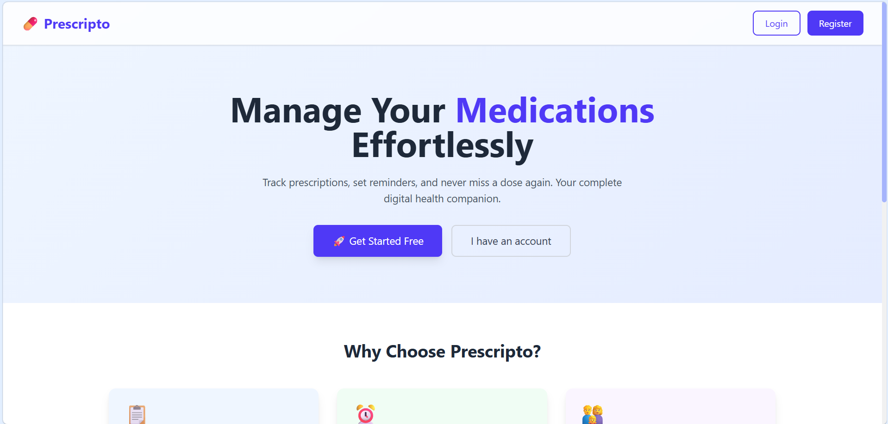

After clicking on Login/Signup here user need to register and log in for Authentication.
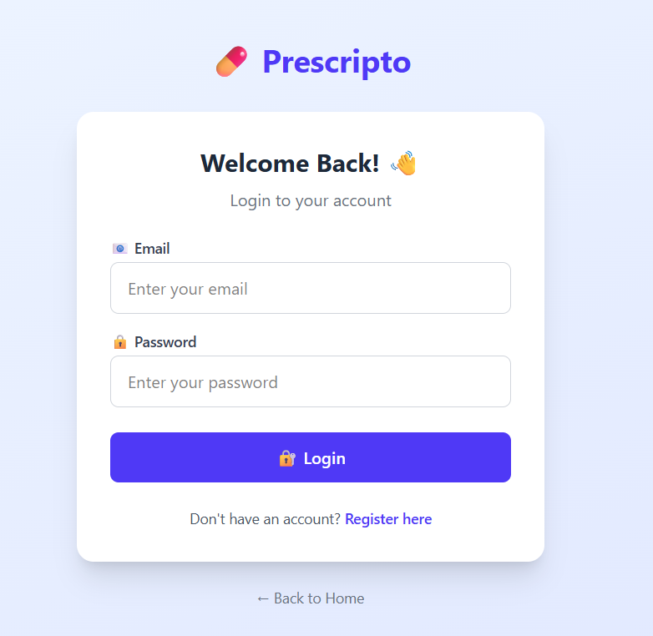
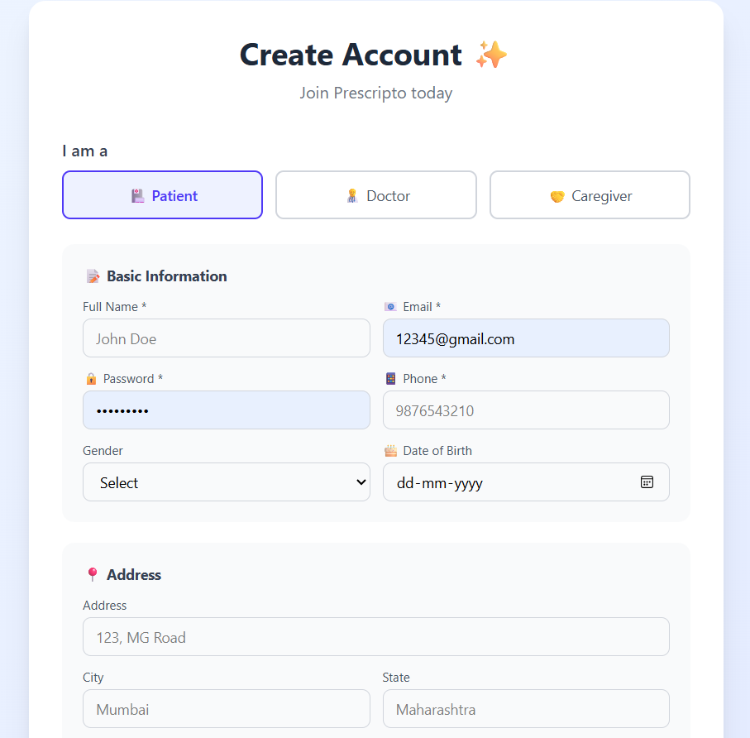

This is Patient Dashboard
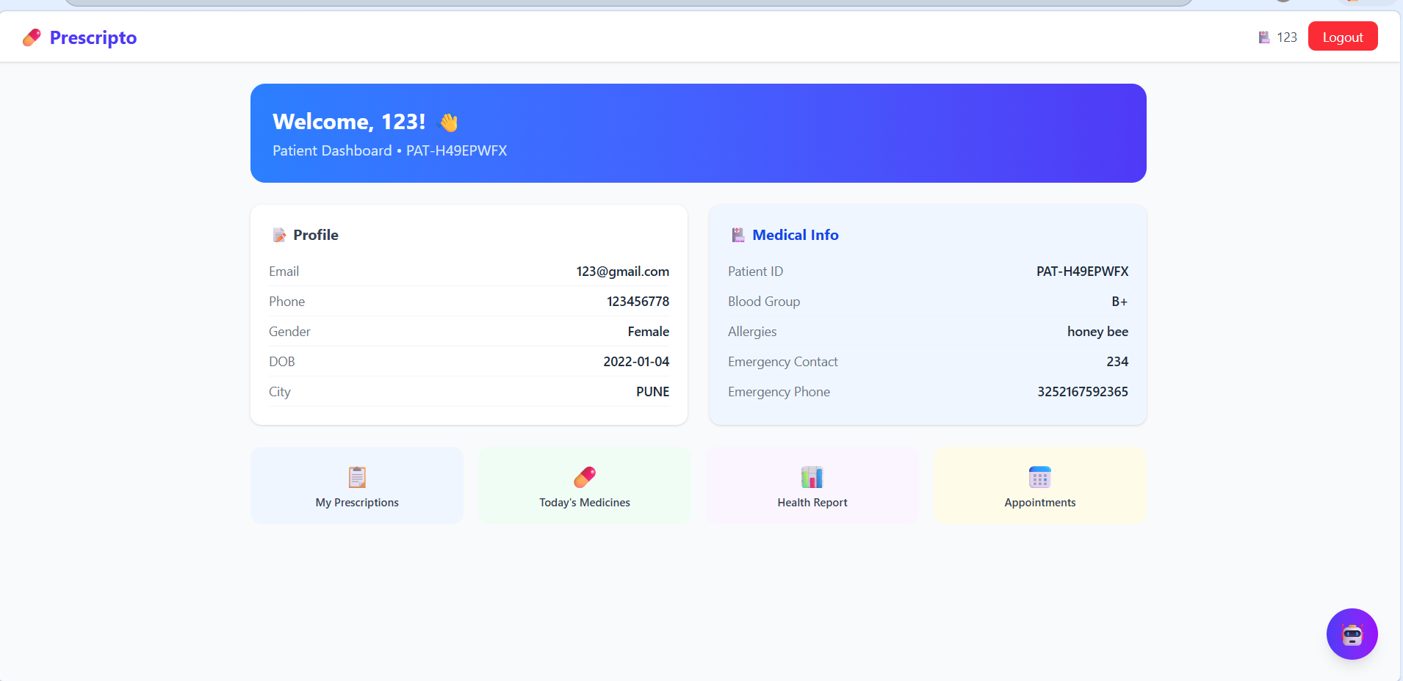

This is Doctor Dashboard
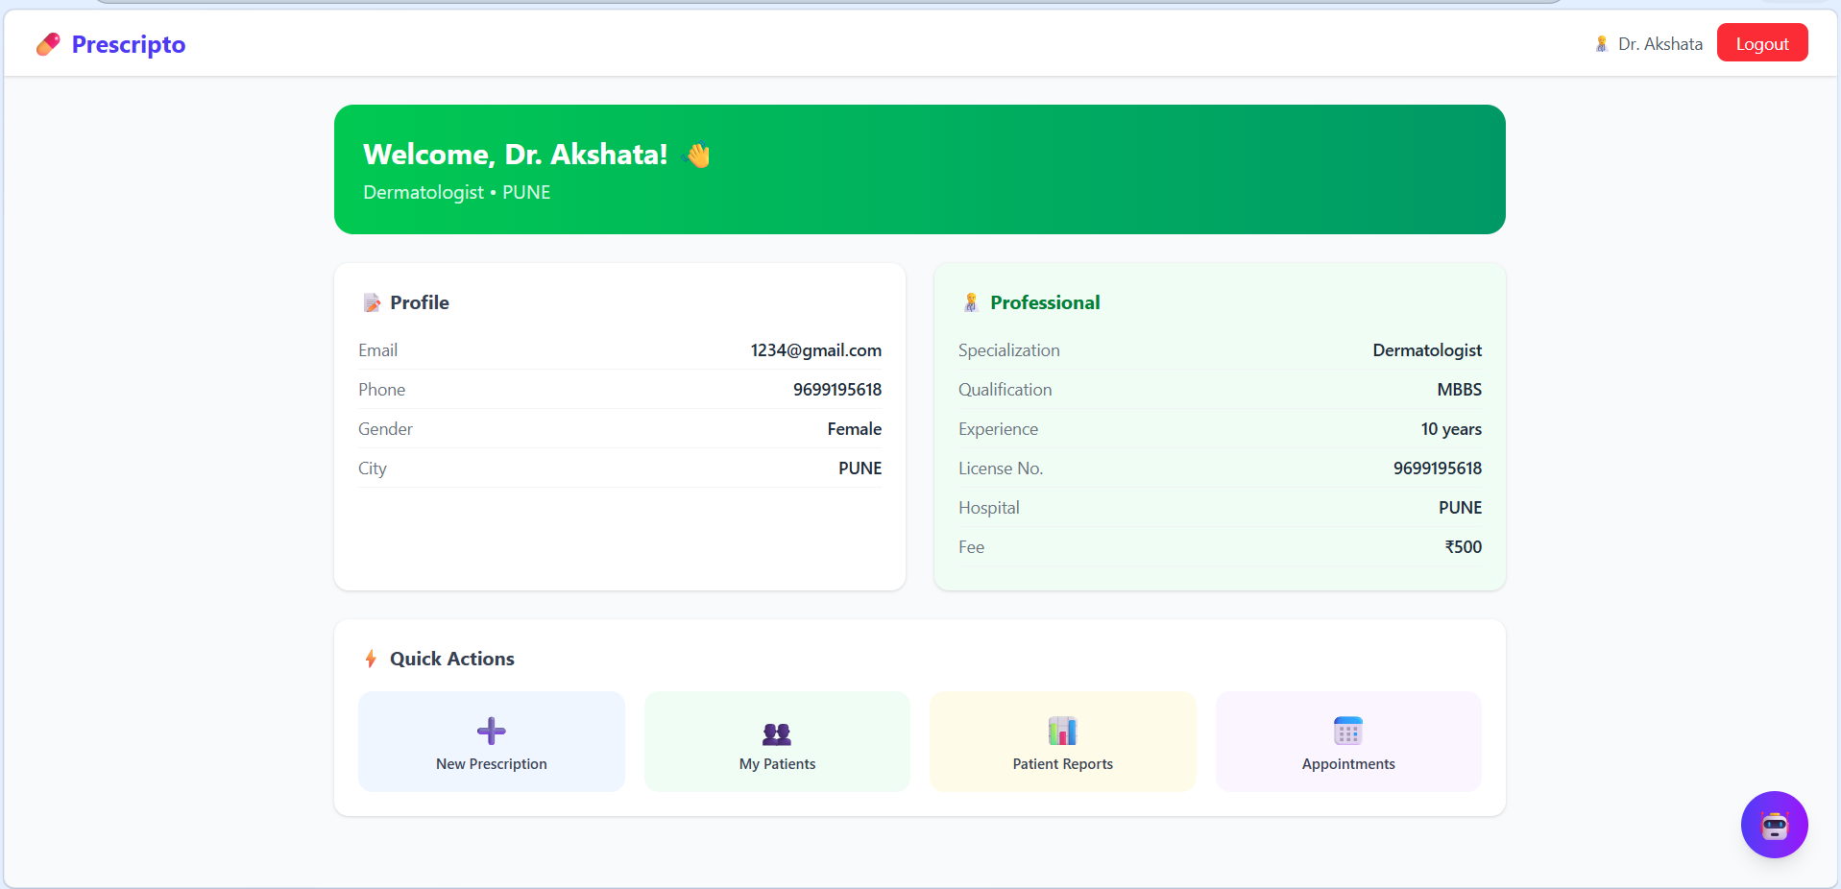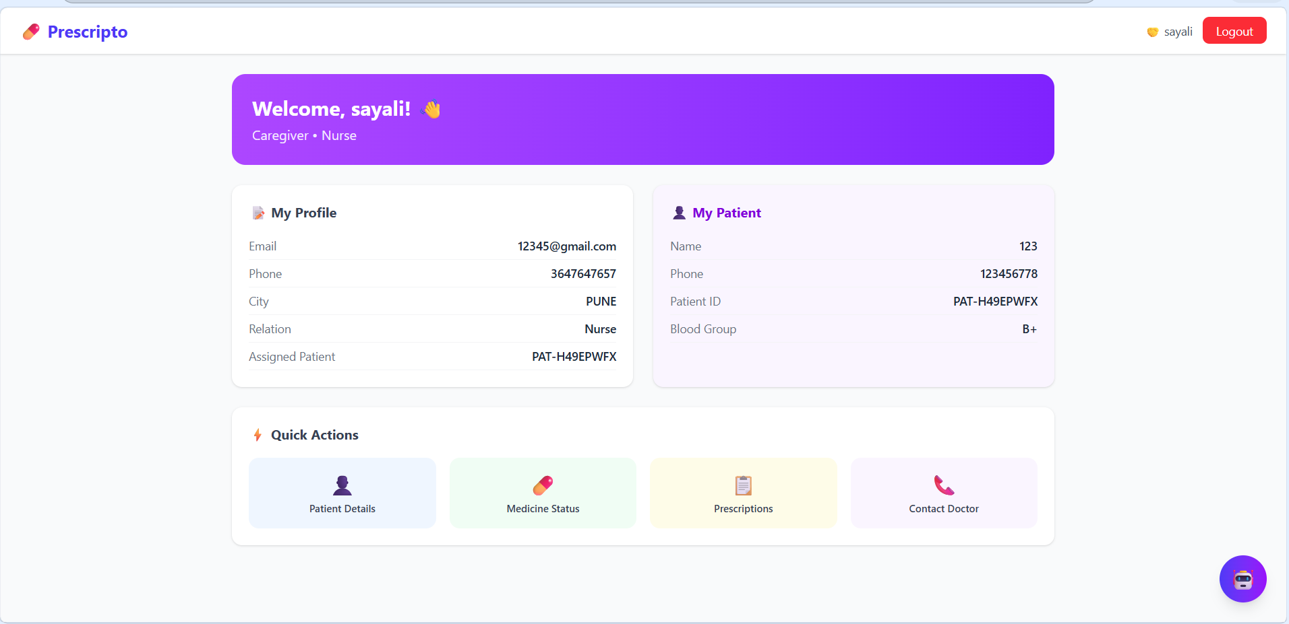

This is Caregiver Dashboard


This is Admin Dashboard
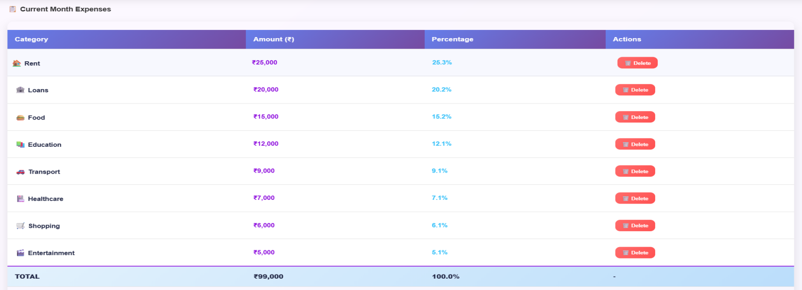

This is our AI HealthCare Assistant(Chatbot).
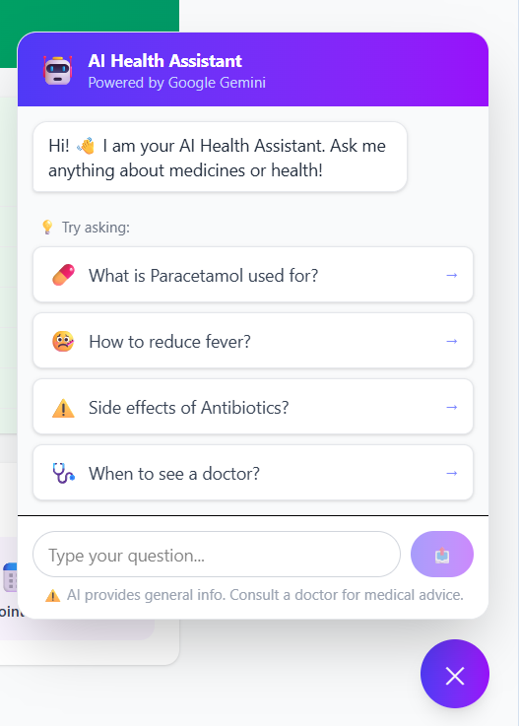

7. Challenges Faced
- Requirement Understanding and Scope Definition : Initially, defining clear and complete system requirements was challenging, especially when incorporating multiple user roles such as Doctor, Patient, Caregiver, and Admin. Ensuring that all functionalities aligned with real-world healthcare needs required careful planning.
- Role-Based Access Implementation : Implementing secure role-based authentication and authorization using JWT was complex, as different users required different levels of access and permissions within the system.
- Backend Integration and API Design : Designing efficient REST APIs and integrating them with the frontend posed challenges in maintaining data consistency, handling requests, and ensuring smooth communication between components.
- Database Design and Data Management : Structuring the database to handle prescriptions, user roles, medication schedules, and logs in an optimized and scalable manner required careful planning and normalization.
- Real-Time Notification System: Implementing automated medication reminders and ensuring timely delivery of notifications required handling scheduling logic and system reliability.
- Caregiver Integration: Adding the caregiver role introduced additional complexity in access control and data sharing, as caregivers needed limited yet meaningful access to patient data.
- Team Coordination : Managing tasks among frontend and backend team members, ensuring proper communication, and maintaining synchronization between modules was a key challenge.
- Testing and Debugging : Identifying and fixing bugs across different modules, especially during integration, required extensive testing and coordination among team members.
- Security and Data Privacy: Ensuring secure handling of sensitive medical data, including encryption and safe authentication practices, was a critical challenge.
- Time Management : Balancing development tasks with academic responsibilities and meeting project deadlines required effective time management and planning.

8. Learnings & Skills Acquired

· Gained hands-on experience in full-stack development.
· Developed backend skills using Java (Spring Boot).
· Learned REST API design and integration.
· Improved database design and management using MySQL.
· Implemented JWT-based authentication for secure access.
· Understood three-tier system architecture.
· Enhanced problem-solving and debugging skills.
· Gained experience in team collaboration and coordination.
· Improved project planning and time management skills.
· Acquired knowledge of healthcare system workflows and data security.

9. Testimonials from team
Team Member 1:
This project enhanced my backend development skills, especially in building REST APIs using Spring Boot and implementing secure authentication mechanisms. It also gave me practical experience in handling real-world healthcare data systems
Team Member 2:
Working on Prescripto helped me strengthen my understanding of database design and API integration. I gained hands-on experience in developing scalable backend systems and managing data efficiently.
Team Member 3:
This project improved my frontend development skills by allowing me to design intuitive and user-friendly interfaces. I learned how to create responsive dashboards and effectively integrate frontend with backend services.
Team Member 4:
Prescripto helped me enhance my UI/UX design skills and understand how to build interactive web applications. I also gained valuable experience in teamwork and implementing real-world project features.

Conclusion
The internship was a valuable learning experience that provided practical exposure to real-world software development. Through the Prescripto project, I applied my technical knowledge to build a meaningful healthcare solution. I improved my skills in backend development, API integration, and database management. Additionally, I developed strong problem-solving, teamwork, and time management skills. Overall, the internship enhanced my technical and professional abilities and prepared me for future career opportunities.

11. Acknowledgements
I would like to express my sincere gratitude to the organization for providing me the opportunity to work on the Prescripto – Online Medication and Prescription Tracking System and gain valuable hands-on experience in software development.
I am especially thankful to my mentor, Vinay Sir, for his constant guidance, support, and valuable insights throughout the project. His mentorship played a crucial role in helping us overcome challenges and improve both our technical and professional skills.
I would also like to thank my team members for their collaboration, coordination, and dedication in successfully completing this project. Their support and teamwork made the entire development process smooth and productive.
Finally, I extend my appreciation to everyone who contributed directly or indirectly to the successful completion of this project and my overall learning experience.

